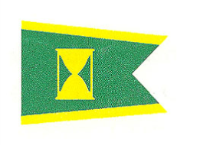
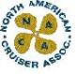
Welcome to the
North American Invitational
Predicted Log Championship
September 22 - 25, 2021
Sponsored by the North American Cruiser Association
Hosted by the San Diego Cruiser Association
and the San Diego Yacht Club

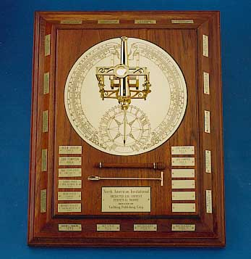

where the best competitor from each of the associations,
the winner of the Coastal Explorer Award for 2019
and the 2019 NAI winner will compete
for the coveted “Noon Cannon” Trophy.

